

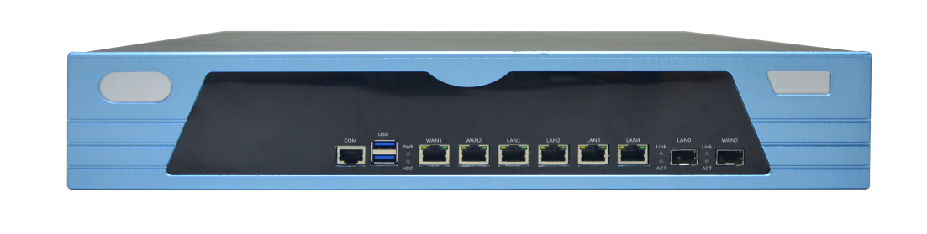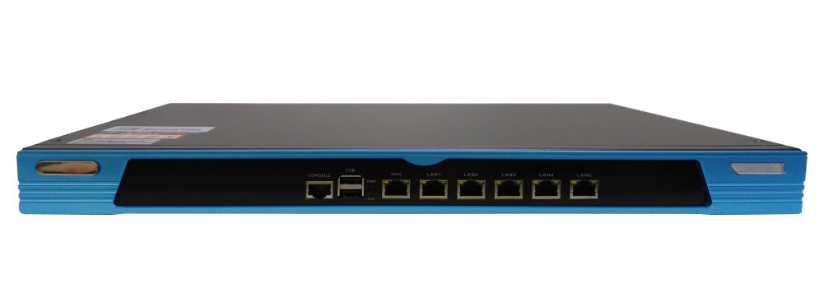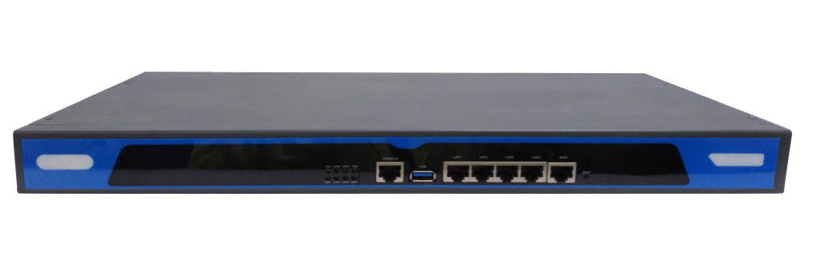

# **MP Series**

Holo-ELV AI Management Platform

## Products Description

TG MP Series Holo-ELV AI Management Platform(Platform in short) is a comprehensive management platform for weak current network integrating computer network, security network, intelligent equipment network management and operation and maintenance. It can solve the unified operation and maintenance needs of multiple sets of business networks under the same network or not. In the case where the computer network and the security and equipment network are not shared, there are multiple sets of independent physical networks in the project. The platform is connected to different physical networks through different LAN ports, and can support up to 5 sets of independent physical networks. In the case where the computer network is shared with security and equipment networks, a set of physical networks in the project undertakes the business of each subsystem. The platform supports the unified operation and maintenance management requirements of different business network equipment and terminals under the premise of achieving the isolation of various business logics.

The platform integrates powerful functions of a professional wireless controller, supports centralized / local forwarding, seamless roaming, load balancing, radio frequency optimization, portal authentication, and other wireless functions, making wireless network deployment, wireless optimization, and troubleshooting of wireless faults simple and easy. Supports built-in authentication server, supports at least 10 authentication types optional, to meet the needs of wireless networking and authentication marketing in various scenarios.

The platform is based on the in-depth management of network equipment and integrates the integrated management of security network and intelligent equipment network. the platform is based on the ONVIF protocol for security and the built-in more than 50 terminal types, which can intelligently identify the security network and intelligent equipment All terminal devices in the network, and visual asset management of all terminals.

The platform supports real-time inspection of the operating status of all devices in the network, intelligently analyzes the quality of the network environment, timely alerts of abnormalities that occur in the network, and accurately locates the location of the faulty node. The artificial intelligence algorithm provides a solution plan to achieve intelligent operation and maintenance of computer networks, security networks, and intelligent equipment networks. the platform linkage cloud supports multi-dimensional alarm strategies, and the alarm information can be actively pushed through WeChat, SMS, email, etc. To the operation and maintenance personnel, and support the login of different terminals and different operating systems such as computers, notebooks, tablets, mobile phones, etc., to achieve the needs of intranet operation and maintenance anytime, anywhere.

Platform is used in conjunction with network equipment to meet the certification and marketing and security audit needs of wired / wireless networks such as government, scenic spots, hospitals, hotels, factories, education, enterprises, and supermarkets. The visual operation and maintenance requirements of the security network and intelligent equipment network in the above scenarios.

## Main Features

* **Integrated Management**

**IP based Integrated Management:**

Support the comprehensive operation and maintenance management of computer networks, security networks, intelligent equipment networks and other business networks, support the integrated operation and maintenance management of multi-service systems on the same network or multi-network multi-service systems, and realize all network devices on the network : Switch, router, wireless AP; terminal equipment: security terminal, various intelligent IP terminals of equipment network, office network computer, printer and other equipment to achieve hyper-converged management. Under the premise of supporting the logical isolation of each business system when networking multi-service systems on the same network, the unified operation and maintenance management of all network-connected devices on one platform; when multi-network multi-service systems are networked, the platform supports The network situation is divided into nets, which supports the statistics of physical networks in asset management, and supports the presentation of multiple physical network topologies in the topology map to achieve the unified management of different physical networks. The platform combines AI intelligent technology and holographic visualization technology to make network operation and maintenance easier and more convenient. While continuously improving the customer's network service experience, it reduces the difficulty and threshold of operation and maintenance, realizes automated visual operation and maintenance, and builds the "operation" of the weak current network around you. Dimension expert ".

**Centralized Management for Switches, APs, Routers,etc:**

1. Centralized Management for TG Switches, switches automatically go on line on the platform without any configuration.

The platform completes the initial basic configuration of all switches in a unified manner, which facilitates the centralized configuration of the switches on the network on the platform during the later business deployment, reducing the time cost and workload of the deployment;

1. The platform supports remote operation and maintenance management of the router, real-time monitoring of routing traffic, and precise real-time control of the router's operating status.The platform supports remote operation and maintenance management of the router, real-time monitoring of routing traffic, and precise real-time control of the router's operating status;
2. It supports centralized management of wireless APs, centralized configuration of APs, and quick discovery of newly-accessed APs. The wireless controller template configuration can be read within 3 seconds after the AP is started. The installation and configuration are convenient and fast, enabling plug and play. The wireless controller one-key configuration release and one-key synchronization functions greatly reduce the workload and cost of installation and maintenance.

**Centralized Management for Terminals**

1. IPC intelligent management based on ONVIF protocol:
2. The platform supports intelligent identification and management of network cameras of many security manufacturers such as Hikvision, Dahua, Uniview, Sony, etc., automatically recognizes IPC, reads and displays IPC IP address, MAC address, manufacturer information, device model, channel name, etc. Information to realize a full range of IPC monitoring and management.
3. The platform supports identification and management of no less than 50 intelligent terminals by default, including NVR, access control, intercom, alarm, patrol and other front and back security equipment, printers, servers, computers and other office equipment, air sensors, temperature and humidity sensors Intelligent speaker network terminals such as IP speakers and broadcasts also support custom terminal types to achieve hyper-converged management of all IP-based devices on the network.
4. Group management:

The platform supports customized group management of terminal devices in the entire network according to the business and terminal deployment area, which is convenient for asset inventory and centralized operation and maintenance management of local perspectives for terminal devices in a business subsystem or a specific area.

* **Global visual management**

**Global asset visual management:**The platform intelligently identifies all network devices and terminal devices on the network, and classifies all the identified devices on the home page (including online and offline numbers), and presents them intuitively in the form of icons to achieve visual management of the entire network of assets.

**Network topology visualization management:**The platform will automatically draw all the front-end and back-end equipment and network equipment identified to generate a global dynamic network topology. The network structure of the network, the connection relationship of the equipment, the location and status of the AP or terminal access, the upstream and downstream traffic of the link, and other information Clearly displayed on the topology map, to achieve visual management of the entire network equipment network.

**Switch port visual management:**The platform supports the visual management of the switch panel. The working status of the switch and the enabled status, port rate, device type and status of the port access of the switch are graphically displayed on the switch panel to achieve The switch panel visually manages the terminal.

**Visual management of flat positions:**The platform supports the import of plane drawings to achieve visual management of APs. In addition to being able to intuitively understand the physical deployment location of APs, in the plane view interface, the AP's online and offline status, channel settings, power size, capacity, terminal negotiation rate, etc. The information of the running status can be presented intuitively. Through the visual interface of the plan view, the running status of the APs in the whole network can be grasped in real time, and the health of the wireless network can be sensed.

**Visual management of Baidu map:**The platform supports centralized management in the cloud, and the cloud imports Baidu eighteen-level maps, which can implement cross-regional and centralized management of all networked platforms by multi-level geographic space such as provinces, cities, districts, counties, and streets.

* **Intelligent operation and maintenance**

**Intelligent inspection of the whole network health index:**The platform supports real-time health inspections of the network environment, equipment operating status, network link status, network security status, etc., and combined with intelligent algorithms to scientifically give a network-wide health index score, which has become an aid to O & M personnel in judging the overall operating status of weak current networks A strong basis.

**Smart alarm**:The platform supports real-time status of intelligent detection devices based on the power status of the terminal / AP, the traffic size of the terminal / AP, the keep-alive mechanism of the terminal / AP, etc. It supports the number of link-based packets and link bandwidth. Intelligent analysis of the communication quality of the link in multiple dimensions such as utilization rate and packet loss of the link. Supports intelligent awareness of the network environment based on the type of packets in the network, the characteristics of the traffic, and actively initiated probe packets. Abnormal prompt warning.

**Accurate fault location**:When an alarm is found when an abnormality is found in the network, the platform will accurately locate the faulty network location and physical location with the help of the dynamic network topology map and plane drawings, and display it in the topology map step by step to identify abnormal devices and abnormal content. It is convenient for the operation and maintenance personnel to know the specific problem of the fault and eliminate the problem in a targeted manner.

**Rich processing plans:**In response to network failures in the network, the platform has built-in a rich library of fault handling strategies for live networks. Based on artificial intelligence algorithms, combined with the types of faults in the live network, timely output of targeted processing plans is provided to allow O & M personnel to deal with live network faults No longer at a loss, to be confident, it is helpful for the operation and maintenance personnel to quickly solve the fault of the current network and improve customer satisfaction.

* **Intelligent self-healing**

With the help of AI intelligent algorithms and big data technology, the platform can monitor and perceive the hidden dangers in the network, warn in advance and start the Intelligent self-healing function to prevent failures before they happen.

**Smart PoE restart:**The platform performs real-time intelligent diagnosis of the running status of the POE power receiving terminal equipment and AP equipment in the network. Once the abnormality is detected, the port automatically turns on and off the POE power supply, and finally achieves the purpose of self-healing terminal and AP. To prevent failures before they happen.

**Loop self-protection:**Once the platform detects a loop in the network, it actively breaks the loop, which does not affect the normal services of the network. After the loop is lifted, the port resumes itself.

* **AC Controller**

**Centralized / local forwarding:**Holo-ELV AI Management Platform M-5-V3 Support local / centralized forwarding mode, according to networking requirements, you can flexibly choose the deployment method.

**AP Centralized Management**:The platform supports centralized management of all APs of the "TG" brand. APs are automatically launched on the platform. The platform uniformly distributes the configuration of APs, which realizes the centralized delivery of the configuration of all APs on the network, greatly reducing wireless The network deployment workload, and the platform also supports batch upgrades of AP versions.

**Seamless Roaming:**The platform supports seamless roaming when deploying wireless networks with APs. When the wireless terminal performs roaming switching between multiple APs, the terminal will not disconnect the SSID association, and the terminal IP address and authentication status remain unchanged, avoiding the tediousness of repeated authentication To allow wireless network users to experience good seamless roaming.

**Load balancing:**The platform supports load balancing based on the number of users and frequency bands. When the platform finds that the load of the AP exceeds the threshold, if there are new users to access, the platform automatically calculates according to the current wireless network environment and connects the users to the lighter load On the AP, by controlling the AP that the wireless terminal accesses, load sharing between the APs is achieved, which not only ensures the maximum number of wireless network terminal accesses, but does not affect the overall experience of the wireless network.

**Intelligent channel optimization:**Wireless signals are everywhere, and there are a lot of interference sources in the frequency bands that allow wireless LANs to work. Therefore, channel conflict is the culprit of poor wireless network experience. The platform can detect the channel settings of the wireless signals around the AP and filter out channel interference through intelligent algorithms. The smallest channel to ensure that each AP can be assigned to the best channel, as much as possible to reduce and avoid channel interference.

**Weak terminal intelligent detection**:The platform monitors the negotiated rate of the wireless terminal under the AP in real time. Once the negotiated rate of the wireless terminal is found to be too low, the terminal is considered to be a weak terminal, and an alert is issued to allow the operation and maintenance personnel to take countermeasures to improve the overall forwarding efficiency of the wireless network.

**Rich authentication strategy:**The platform supports no less than 10 authentication strategies, including: free authentication, one-key authentication, WeChat authentication, SMS authentication, key authentication, ID card authentication, built-in account authentication, external server authentication, visitor authentication, billing authentication, etc. Support different authentication combination strategies based on SSID, the authentication type can be selected, and Rich authentication strategy can fully meet users' multiple authentication needs.

* **Remote mobile operation and maintenance**

**Multi-platform login:**The platform B / S design architecture can realize the login management requirements of different terminals (computers, notebooks, PADs, mobile phones) and different operating systems (Windows, Linux, mac-OS, Android). At the same time, the platform supports cloud centralized management, which can realize cloud jump Switch to intranet, so that operation and maintenance are no longer restricted by terminals and scenarios.

**Multiple Alarm ways:**The platform supports various alarm ways such by WeChat, email, SMS, etc. to actively push the alarm information to the operation and maintenance personnel, so that the operation and maintenance personnel can immediately know the failure of the intranet, and deal with network problems in a timely manner, and restore the normal operation of the network as soon as possible.

## Product Specifications

|  |  |  |  |  |
| --- | --- | --- | --- | --- |
| **Product Information** | | | | |
| Product Model | **MP-3** | | **MP-5** | **MP-7** |
| **Hardware specifications** | | | | |
| Number of AP management | 32 by default and max.128 | | 128 by default and max.1024 | 128 by default and max.2048 |
| Management of Switch ports | Only 200 | | 200 ports by default and Max. 4000 ports | 200 ports by default and Max. 10000 ports |
| RAM | 256MB | | 2GB | 8GB |
| Flash | 32MB | | 32GB | 32GB |
| Dimension(Length Width Height) | 440×285×44.5mm | | 440×285×44.5mm | 440×407×92mm |
| Input Power | AC:110-240V 50-60Hz | |  |  |
| Power Consumption | <30W | | <70W | <250W |
| Operating environment | Operating temperature: 0°C -50°C | | | |
| Relative humidity: 5%–95% (non-condensing) | | | |
| **Software specifications** | | | | |
| Network | Protocols | 802.1q VLAN | | |
| TNMP(private),SNMP supported | | |
| TCP/IP,HTTPS,HTTP,SSH,Telnet | | |
| DHCP Server,DNS Client,802.11 | | |
| NAT | | |
| ONVIF | | |
| Scene Definition | Default Scene | Computers, Transmission Devices, ELV Terminals | | |
| Customized Scene | Not supported | | |
| Comprehensive operation &maintenance management | Multi-network integrated management | Supports simultaneous management of multiple sets of physical networks  (corresponding to multiple sets of business systems） | | |
| Integrated management on the same network | Support the unified management of the same physical network carrying multiple business systems | | |
| Network Equipment Management | Centralized Management for TG Switch, Router,AP | | |
| Weak current terminal management | Support the unified management of all IP terminals of security terminal equipment and intelligent equipment network | | |
| Device status monitoring | Real-time statistics and monitoring of the number and online status of devices in the network, and graphical display on the home page | | |
| Support statistics on the historical online status of IPC within 24 hours, within a week and within a month | | |
| Support historical traffic statistics within 24 hours of NVR | | |
| Group Management | Support group management of global equipment according to business and deployment area, which is convenient for asset inventory and operation and maintenance management of a business subsystem or equipment in a specific area | | |
| Visual management | Dynamic Topology | Support the automatic generation of all the identified network architecture diagrams of all the identified devices, real-time display of the uplink and downlink traffic of each link in the network, and the operating status of all network devices (online, offline, traffic, etc. abnormal), presenting detailed information of terminal devices (MAC, IP, manufacturer information, IPC channel name, device model, device alias, etc.) and its access network location (access switch port information) | | |
| Switch port visualization | Support the switch to display the enable status of the port, the type of terminal connected to the port and its working status in the form of a panel  Support graphical display of the working status of the switch, including: viewing of comprehensive information such as the device name, IP address, device temperature, and operating time | | |
| 2D Panoramic | 2D plan view, import project plan drawings, realize visual management of AP / terminal plane position | | |
| Based on the perspective of plane drawings, it can realize AP alarm visualization, offline visualization, weak terminal visualization, channel interference visualization, terminal load visualization, channel distribution visualization, operation and maintenance configuration visualization, etc.  Realize IPC alarm visualization, status visualization and configuration visualization. | | |
| Neighbor AP information visualization (neighbor AP ssid, mac, channel, signal strength, AP identification, phishing AP identification), discover interference and network risks, and provide real-time alarms and suggestions | | |
| 3D Panoramic | 3D stereoscopic view, seeing the operation of each part of the wireless network security network from a bird's eye perspective. | | |
| Wifi Probe | Support AP (partial AP support) scanning and statistics of wifi probe frames, analysis of peripheral terminals | | |
| Intelligent operation and maintenance | Intelligent inspection | The platform scans the entire network in multiple dimensions such as the network environment, terminal status, link status, etc., combined with intelligent algorithms, evaluates the network health index, and then has a comprehensive assessment of the operation status of the entire network | | |
| Smart alarm | Support offline alarm of terminal equipment | | |
| Support offline alarm of network equipment | | |
| Support real-time alarm of network loop | | |
| Support real-time warning of broadcast storm | | |
| Support real-time alarm of IP address conflict | | |
| Support real-time alarm of link congestion | | |
| Support real-time alarm for link packet loss | | |
| Support real-time alarm for low IPC traffic | | |
| Support backbone link rate negotiation abnormal alarm | | |
| Support AP offline real-time alarm | | |
| Support weak terminal real-time alarm | | |
| Support channel conflict alarm | | |
| Support phishing AP alarm | | |
| Intelligent self-healing | POE intelligent diagnosis:  Real-time intelligent diagnosis of the running state of the POE power receiving terminal equipment, once the terminal is detected abnormally, the POE power supply of the port is automatically opened and closed, and the purpose of the self-healing terminal is finally achieved | | |
| Intelligent timing restart of POE port | | |
| Intelligent timing restart of POE port | | |
| AC Functions | Networking mode | Side way | | |
| Forwarding | Local/Central/Mixed forwarding | | |
| DHCP Server | User mode（Assign IP address for Centralized forwarding users） | | |
| Public Mode（Assign IP for wired, Wireless users） | | |
| Monitor Statistics | 24 hours,30 minutes,1month on line users statistics | | |
| Support classification statistics of wireless terminal negotiation rate | | |
| Support the statistics of AP belt machine distribution | | |
| AP Management | 16 *SSID,Support SSID hiding | | |
| MAX. 512 *SSID templats supported | | |
| VLAN SSID,support different SSID in different VLAN | | |
| AP fast automatic discovery, configuration automatic delivery, one-click synchronization | | |
| Seamless Roaming | | |
| Support AP batch upgrade, restart, scheduled restart, configuration reset, etc. | | |
| Neighbor channel scanning, rogue AP detection, signal interference detection, channel detection, etc. | | |
| Support AP smart point marker | | |
| User Management | Access control based on the number of AP and SSID users | | |
| Load balancing access control based on AP users and frequency band | | |
| Support authentication and access to black and white lists | | |
| Support the speed limit of the terminal bandwidth | | |
| Weak terminal monitoring | | |
| Marketing Authentication | SSID-Based Authentication :Authentication-free, one-key authentication, WeChat authentication, SMS authentication, key authentication, built-in account authentication, Radius authentication, external server authentication, billing authentication, visitor authentication | | |
| Internet time limit setting for authenticated users | | |
| Support custom ≤5 ads display and push | | |
| Radio frequency optimization | Support 5G access priority | | |
| Support AP broadcast suppression | | |
| Support wireless air interface resource optimization | | |
| Support 2.4G and 5G channel and power optimization | | |
| LED and RF can be turned off according to the scene | | |
| Switch Management | Status Monitor | Supports visual monitoring and management of the switch's port status, flow rate, negotiated rate, enable status, temperature, etc. | | |
| Block Monitor | Support port bandwidth usage statistics, real-time understanding of network communication quality | | |
| Management | Support batch configuration management of switch aliases, IP addresses, user passwords, etc. | | |
| Supports visual configuration management of scheduled restart, intelligent restart, enable, and power supply of PoE switches | | |
| Maintenance | Supports operation and maintenance operations such as restart, upgrade, reset, and factory reset of managed PoE switches and switches | | |
| Open Management | Support switch device management of mainstream third-party SNMP protocol | | |
| Router Management | Router Management | Jump from Platform to Router Management Page | | |
| Flow Monitoring | Support real-time statistics of upstream and downstream traffic | | |
| Intelligent terminal management | Custom smart terminal | By default, the platform supports the identification of no less than 20 types of intelligent terminal devices, and realizes unified visual management of intelligent devices such as access control, intercom, alarm, patrol, light control, and temperature control. | | |
| Terminal jump to login | Support remote remote login of security intranet devices and remote management of IPC, NVR and other devices | | |
| IT  Equipment Mangement | PC Recognition | Supported | | |
| Printer Recognition | Supported | | |
| Server Recognition | Supported | | |
| Security | Black/White List | Black/White Authentication | | |
| Security Protection | Support security protection for unauthorized access equipment | | |
| ARP Protection | Supported | | |
| Encryption | WPA2-PSK supported for WiFi | | |
| Privilege management | Supported Login authority configuration management, hierarchical authority control | | |
| ACL Management | Supported ACL Configuration management, flexible configuration management to block and release specific URL, IP, ICMP, TCP, UDP, port, etc. | | |
| Force users to go offline | supported | | |
| Wireless security audit | supported | | |
| Outdated detection | Supported Outdated login detection | | |
| Anti-rubbing net | supported | | |
| Alarm | Real-time visual alarm, alarm notification, cloud alarm, SMS alarm | | |
| System Management | System Configuration | System restart, upgrade and factory reset | | |
| AP and port license import | | |
| Configuration import and export | | |
| English/Chinese supported | | |
| Maintenance management | Supported Link integrity detection | | |
| Manage via WEB Telnet | | |
| Supported Real-time recording of access and operation logs | | |
| Supported Multi-level permission account management | | |
| Configure to join the cloud to realize cloud remote management | | |
| supportedping,nslookup,traceroute,ip Usage diagnosis | | |
| Supported Cloud remote management, WeChat public account mobile operation and maintenance management | | |

## Order Information

|  |  |
| --- | --- |
| **Product Information** | **Detailed information** |
| MP-3 | 5*10/100/1000 Base-T ports, 2*AP Control supported by default and can be expanded upto 128*AP. 200*Ports of Switches. |
| MP-5 | 6*10/100/1000 Base-T ports, 28*AP Control supported by default and can be expanded upto 1024*AP.200*Ports of Switches,upto 4000*ports. |
| MP-7 | 6*10/100/1000 Base-T ports,2* 1G/10 GE Base-X SFP+ ports, 28*AP Control supported by default and can be expanded upto 2048*AP. 200*Ports of Switches,upto 10000*ports. |
| **AP management license** | |
| AC-license-16 | AC license of 16*AP |
| AC-license-32 | AC license of 32*AP |
| AC-license-64 | AC license of 64*AP |
| AC-license-128 | AC license of 128*AP |
| AC-license-256 | AC license of 256*AP |
| AC-license-512 | AC license of 512*AP |
| **Switch management license** | |
| INMP-license-80 | License for 80*Ports of Switches and 12 month upgrade service |
| INMP-license-160 | License for 160*Ports of Switches and 12 month upgrade service |
| INMP-license-320 | License for 320*Ports of Switches and 12 month upgrade service |
| INMP-license-640 | License for 640*Ports of Switches and 12 month upgrade service |
| INMP-license-1280 | License for 1280*Ports of Switches and 12 month upgrade service |

|  |
| --- |
| **Shenzhen TG-NET Botone Technology CO. Ltd.**  3rd Floor,No.17,Langrong Road, Xinshi Community,Dalang Street,Longhua District,Shenzhen  Website: http://www.tg-net.net  E-mail: cherry.tan@tg-net.cn |