

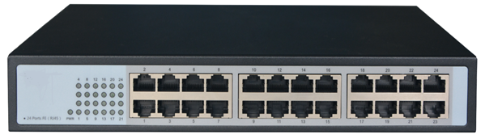

# **SF1024D**

24-Port 10/100Mbps Unmanaged Switch

## Products Description

SF1024D is a 24-port fast Ethernet switch developed by TG, offering 24 10/100 Mbps RJ45 ports. Equipped with large packet buffer, it also ensures smooth streaming even when 23 HD IP cameras are working simultaneously. SF1024D is a perfect choice for small and medium-sized IP surveillance projects and enterprises to have network.

## Main Features

* Comply with IEEE802.3, IEEE802.3i, IEEE 802.3u, IEEE802.3x,IEEE802.3az Ethernet standard;
* 24 10/100Mbps adaptive RJ45 ports, support auto flip function (AutoMDI/MDIX);
* Support IEEE802.3x full-duplex flow control function and half-duplex back pressure flow control function;
* Support IEEE802.3az Energy-saving Ethernet (EEE) technology;
* 4K automatic learning and automatic aging MAC address;
* Easy-to-understand LEDs indicate the connection and data transmission status of the port;
* External power supply, exquisite iron shell structure design, suitable for desktop installation

## Product Specifications

|  |  |
| --- | --- |
| **Product Information** | |
| Product Model | **SF1024D** |
| **Hardware specifications** | |
| Fixed Ports | 24*10/100 Base-TX ports |
| Transmission Media | Recommended: CAT5/5e UTP or better |
| Switching Capacity | 4.8G |
| Forwarding Rate | 10M:14880pps/port |
| 100M:148809pps/port |
| Temperature | Operating temperature: (0 - 40)°C  Storage temperature: (-40 - 70)°C |
| Humidity | Operating humidity: (10% - 90%) RH, non-condensing  Storage humidity: (5% - 90%) % RH, non-condensing |
| Dimensions(L*W*H) | 270*180*44mm |
| Power | AC 100~240V,50Hz~60Hz,5V/2A |
| Power consumption | 5.2W |
| Weight | <2Kg |
| Lightning protection | 2KV |
| MAC address table | 4K |
| LED Indicator | Power,Link/Act |
| **Software specifications** | |
| Forwarding mode | Store-and-forward |
| MAC address learning | Auto learning & auto aging |

## Order Information

|  |  |
| --- | --- |
| **Product Information** | **Detailed information** |
| SF1024D | 24*10/100 Base-TX ports. |

|  |
| --- |
| **Shenzhen TG-NET Botone Technology CO. Ltd.**  3rd Floor,No.17,Langrong Road, Xinshi Community,Dalang Street,Longhua District,Shenzhen  Website: http://www.tg-net.net  E-mail: cherry.tan@tg-net.cn |