

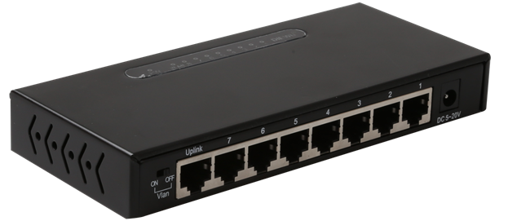

SF1208
8-Port 10/100Mbps Unmanaged Switch

Products Description
SF1208 is a 8-port fast Ethernet switch developed by TG, offering 8 10/100 Mbps RJ45 ports. Equipped with large packet buffer, it also ensures smooth streaming even when 7 HD IP cameras are working simultaneously. SF1208 is a perfect choice for small and medium-sized IP surveillance projects and enterprises to have network.

Main Features
- Comply with IEEE802.3, IEEE802.3i, IEEE 802.3u, IEEE802.3x,IEEE802.3az Ethernet standard;
- 8 10/100Mbps adaptive RJ45 ports, support auto flip function (AutoMDI/MDIX);
- Support IEEE802.3x full-duplex flow control function and half-duplex back pressure flow control function;
- Support IEEE802.3az Energy-saving Ethernet (EEE) technology;
- 1K automatic learning and automatic aging MAC address;
- Easy-to-understand LEDs indicate the connection and data transmission status of the port;
- External power supply, exquisite iron shell structure design, suitable for desktop installation
- With VLAN on enabled by the mode toggle, ports 1 to 8 are isolated from each other,enabling the switch to isolate broadcast storm, improving LAN security and data transmission.

Product Specifications
Product Information
Product Model | SF1208
Hardware specifications
Fixed Ports | 8*10/100 Base-TX ports
Transmission Media | Recommended: CAT5/5e UTP or better
Switching Capacity | 1.6G
Forwarding Rate | 10M:14880pps/port
Forwarding Rate | 100M:148809pps/port
Temperature | Operating temperature: (0-40)°C  Storage temperature: (-40 - 70)°C
Humidity | Operating humidity: (10% - 90%) RH, non-condensing  Storage humidity: (5% - 90%) % RH, non-condensing
Dimensions(L*W*H) | 160*72*24mm
Power | DC:5V 0.5A
Power consumption | 1.5W
Weight | <0.3Kg
Lightning protection | 2KV
MAC address table | 1K
LED Indicator | Power,Link/Act
Software specifications
Forwarding mode | Store-and-forward
MAC address learning | Auto learning & auto aging
Vlan | VLAN isolation;

Order Information
Product Information | Detailed information
SF1208 | 8*10/100 Base-TX ports

Shenzhen TG-NET Botone Technology CO. Ltd.
3rd Floor,No.17,Langrong Road, Xinshi Community,Dalang Street,Longhua District,Shenzhen

Website: http://www.tg-net.net
E-mail: cherry.tan@tg-net.cn

