

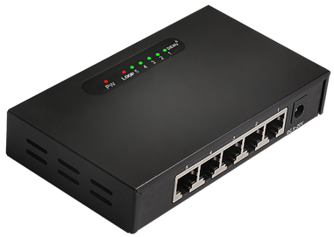

# **SG1005T**

5-Port Gigabit Unmanaged Switch

## Products Description

SG1005T is an unmanaged gigabit switch with 5 10/100/1000Mbps auto-negotiation RJ45 ports. Wire-speed forwarding rate of each port is up to 1000Mbps. SG1005T supports 9k Jumbo Frame to increase the forwarding rate of large files in order to boost network erformance . Lightning proof level is up to 2KV to ensure the stability and safety when you surf the internet. SG1005T is the ideal choice for small & medium enterprises,schools,small offices to upgrade gigabit network.

## Main Features

* Supports IEEE 802.3,IEEE 802.3u,IEEE802.3ab,IEEE802.3az,IEEE802.3x.
* Supports MAC address auto-learning and auto-aging.
* Five 10/100/1000Mbps Auto MDI-MDIX RJ45 port.
* Plug-and-play installation for convenience.
* Store and forward mode operates.
* Green Ethernet Technology,Reduces power on a port when no link is detected;Adjusts power on a port bydetecting the length of the connected cable.
* LED indicators for monitoring power, link/activity.
* External power supply, exquisite design, suitable for desktop install and use.

## Product Specifications

|  |  |
| --- | --- |
| **Product Information** | |
| Product Model | **SG1005T** |
| **Hardware specifications** | |
| Fixed Ports | 5*10/100/1000M Base-T ports |
| Transmission Media | Recommended: CAT5/5e UTP or better |
| Switching Capacity | 10G |
| Forwarding Rate | 10M:14880pps/port |
| 100M:148809pps/port |
| 1000M:1488090pps/port |
| Temperature | Operating temperature: (0 - 40)°C  Storage temperature: (-40 - 70)°C |
| Humidity | Operating humidity: (10% - 90%) RH, non-condensing  Storage humidity: (5% - 90%) % RH, non-condensing |
| Dimensions(L*W*H) | 124*72*24mm |
| Power | DC:5V 0.5A |
| Power consumption | 2W |
| Weight | <0.5Kg |
| Lightning protection | 2KV |
| MAC address table | 1K |
| LED Indicator | Power,Link/Act |
| **Software specifications** | |
| Forwarding mode | Store-and-forward |
| MAC address learning | Auto learning & auto aging |

## Order Information

|  |  |
| --- | --- |
| **Product Information** | **Detailed information** |
| SG1005T | 5*10/100/1000 Base-T ports |

|  |
| --- |
| **Shenzhen TG-NET Botone Technology CO. Ltd.**  3rd Floor,No.17,Langrong Road, Xinshi Community,Dalang Street,Longhua District,Shenzhen  Website: http://www.tg-net.net  E-mail: cherry.tan@tg-net.cn |