

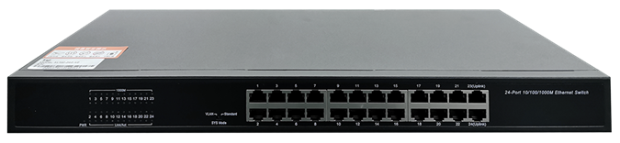

# **SG1024**

24-Port Gigabit Unmanaged Switch

## Products Description

SG1024 is wire-speed Layer 2 Ethernet Switches, adopting plug-and-play design, no configuration. Besides the excellent forwarding capacity, switch is with high security reliability. It adopt carrier class power protection to prevent against lightning, overpressure and surging, keeping excellent working performance in bad environments. Switch energy-saving design as well, which make they the most cost-efficient choice for access switches.

## Main Features

* **Non-blocking High-speed Forwarding**

Supports L2 level wire-speed switching, which enables all ports to forward packets without blocking.

* **Support MDI/MDIX Function**

Plug-and-play design, automatically identify the network cable types( straight forward cable or cross-over cable) and communicate normally.

* **Support Auto-negotiation of port rate**

Support 10/100/1000M multirate terminal, automatically identify the terminal network card rate and duplex mode, reducing maintenance requirements;

The LED indicator can dynamically show the different operation rate.

* **Innovative Energy Saving Design, the leader of low-carbon communication**

Support IEEE 802.3az(Energy Efficient Ethernet ), port energy detection, CPU variable-frequency and device hibernate technology, greatly reducing energy consumption and noise without compromising performance and stability.

## Product Specifications

|  |  |
| --- | --- |
| **Product Information** | |
| Product Model | **SG1024** |
| **Hardware specifications** | |
| Fixed Ports | 24*10/100/1000 Base-T ports . |
| Transmission Media | Recommended: CAT5/5e UTP or better |
| Switching Capacity | 48G |
| Forwarding Rate | 10M:14880pps/port |
| 100M:148809pps/port |
| 1000M:1488090pps/port |
| Temperature | Operating temperature: (0 - 40)°C  Storage temperature: (-40 - 70)°C |
| Humidity | Operating humidity: (10% - 90%) RH, non-condensing  Storage humidity: (5% - 90%) % RH, non-condensing |
| Dimensions(L*W*H) | 440*170*44mm |
| Power | AC 100~240V,50Hz~60Hz,12V/1.5A |
| Power consumption | 15W |
| Weight | <2.5Kg |
| Lightning protection | 2KV |
| MAC address table | 8K |
| LED Indicator | Power,Link/Act |
| **Software specifications** | |
| Forwarding mode | Store-and-forward |
| MAC address learning | Auto learning & auto aging |

## Order Information

|  |  |
| --- | --- |
| **Product Information** | **Detailed information** |
| SG1024 | 24*10/100/1000 Base-T ports |

|  |
| --- |
| **Shenzhen TG-NET Botone Technology CO. Ltd.**  3rd Floor,No.17,Langrong Road, Xinshi Community,Dalang Street,Longhua District,Shenzhen  Website: http://www.tg-net.net  E-mail: cherry.tan@tg-net.cn |