

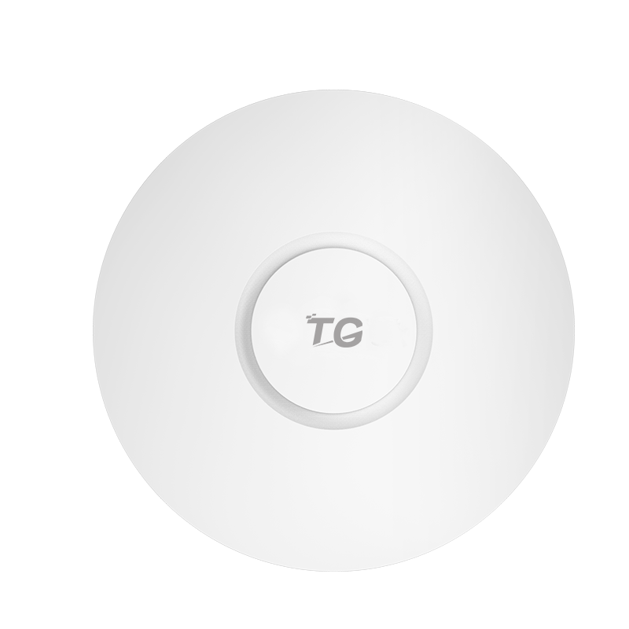

# **CAP4-300**

11n 300M Wireless Ceiling Mount Access Point

## Products Description

CAP4-300 Indoor Ceiling 802.11n Access Point is TG's latest fat and thin integration AP, the maximum rate of 300Mbps, support 802.11b / g / n protocol. Support wireless roaming, load balancing, local forwarding, user isolation and other functions. CAP4-300 maximum RF transmit power 20dBm, built-in 2 3dBi gain smart antenna, is ideal for free scene wireless coverage needs for small and medium-sized hotels, businesses, restaurants, business, entertainment and other applications.

## Main Features

* **High performance panel solutions**

The WAP4-300 utilizes Qualcomm's professional chips and excellent hardware configurations to provide a 300M high-performance panel solution for low latency, terminal intensive, and complex applications in commercial WiFi and other scenarios. WAP4-300 supports 802.11b / g / n protocol, 2.4G single frequency dual stream, provides a wider signal coverage, to provide users with high quality Internet experience.

* **Intelligent RF management**

The CAP4-300 wireless access point provides automatic channel adjustment. Through the exclusive RF detection and RF management algorithm to optimize the RF coverage effect. When the AP signal is subject to external strong signal interference, through the control AP automatically switch to the appropriate working channel to avoid interference signal to ensure the smooth flow of WLAN communication.

* **Local forwarding**

The CAP4-300 combines the multi-service cloud intelligent management platform to enable the local forwarding mode, which greatly reduces the forwarding traffic of the multi-service cloud intelligent management platform and alleviates the traffic pressure. In the case of the multi-service cloud intelligent management platform, Affecting the normal communication of the wireless network.

* **Intelligent certification management**

CAP4-300 with multi-service cloud intelligent management platform can be achieved based on SSID. The authentication methods include: authentication-free, one-key authentication, WeChat authentication, SMS authentication, key authentication, built-in account uthentication, Radius authentication, and external server authentication. A wealth of authentication strategies to meet the needs of a variety of user authentication.

* **Smart seamless roaming and load balancing**

Wireless user association CAP4-300, in the wireless signal coverage within the mobile, you can ensure seamless roaming in the two-tier network, and the user in the process of roaming network business is not interrupted. The CAP4-300 supports the load balancing based on the number of users. When the multi-service cloud intelligent management platform finds that the load of the AP exceeds the threshold, if the new user accesses, the multi-service cloud intelligent management platform automatically calculates the AP according to the current wireless network environment. Into the lighter load AP.

* **Link awareness, smart switch**

CAP4-300 supports Fat / Fit two modes of operation, according to the current network conditions for intelligent switching. Which can achieve the traditional "Fit AP + AC" centralized network architecture, when the multi-service cloud intelligent management platform failure occurs, CAP4-300 also through the TG private agreement, rapid perception of abnormal, intelligent switch to Fat mode, to continue the data Forwarding.

* **Plug and play**

CAP4-300 work in Fit (thin) mode, in the field installation and post-maintenance, AP no need to reconfigure, multi-service cloud intelligent management platform to quickly find access to the new AP, AP start 3 seconds to complete the template configuration, Convenient. Multi-service cloud intelligent management platform can be a key release configuration, AP batch synchronization configuration, greatly reducing the installation, operation and maintenance costs.

## Product Specifications

|  |  |
| --- | --- |
| **Product Information** | |
| Product Model | **CAP4-300** |
| **Hardware specifications** | |
| Fixed port | 2*10/100M RJ45 |
| Maximum Data Rate | 300Mbps |
| Max Rf Transmit Power | 20dBm |
| Internal Antennas | Built-in 2 2 * 2 intelligent omnidirectional antenna (gain 3dBi) |
| Operating frequency band | 802.11b/g/n: 2.4 GHz to 2.483 GHz (China) |
| Power Consumption | <8W |
| Dimensions | 200*200*18mm; |
| PoE | 802.3af power supply supported  DC:48V 0.32A |
| Receiver Sensitivity | 802.11n（2.4GHz） |
| Operating/storage temperature | -10°C~50°C/-35°C~75°C |
| Operating humidity | 5%~90%(non-condensing) |
| Ingress Protection Rating | IP41 |
| MTBF | >25000H |
| **Software specifications** | |
| System Status | AP Model, AP Name, Up Time, IP&MAC Address, SSID Encryption |
| VLANs | 802.1Q, 4094 VLAN IDs (1 to 4094) and SSID-based VLAN assignment |
| Blacklist and whitelist | Static whitelist and blacklist are supported |
| Wireless Mode | 11b,11g,11b/g,11b/g/n,11n |
| BSSIDs | 16 |
| Broadcast Storm Suppression | Supported |
| SSID Hiding | Supported |
| User Isolation | Supported |
| Automatic channel control | Supported |
| Automatic power adjustment | Supported |
| Clients Limit | Connected user number limitation for every SSID |
| Bandwidth restriction | STA- or SSID-based rate limiting is supported from AP Controller |
| Wireless Security | 64/128 WPA-PSK,WPA2-PSK,WPA,WPA2 |
| Authentication mode | authentication-free, one-key authentication, WeChat authentication, SMS authentication, key authentication, built-in account uthentication, Radius authentication, and external server authentication. |
| Local Forward | Supported |
| Fat/Fit Mode | Supported |
| Advanced Settings | Beacon Interval, RTS Threshold, Data Beacon Rate (DTIM),Long/Short Preamble, Short Gi, A-MPDU,A-MSDU,WMM |
| management | Telnet, HTTP, AP Controller |
| Access Control | Connect limitation based on mac address |
| Client Association Status | Supported |
| Username Management | Supported from Web UI or AP Controller |
| Firmware Upgrade | Supported from Web UI or AP Controller |
| Backup & Restore | Supported |
| Reset/Reboot Device | Supported from Web UI or AP Controller |
| System Log | Supported |
| Reboot Schedule | Supported |

## Order Information

|  |  |
| --- | --- |
| **Product Information** | **Detailed information** |
| CAP4-300 | 2.4G 11n 300Mbps, 1 x uplink WAN interface +1 x downlink LAN interface 100M Port,Power supply：DC-48V/0.32A or POE-IEEE802.3at. |

|  |
| --- |
| **Shenzhen TG-NET Botone Technology CO. Ltd.**  3rd Floor,No.17,Langrong Road, Xinshi Community,Dalang Street,Longhua District,Shenzhen  Website: http://www.tg-net.net  E-mail: cherry.tan@tg-net.cn |