

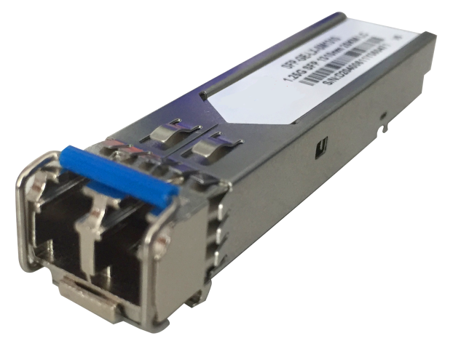

# **Gigabit optical module**

## Products Description

Standard SFP module, used for campus network SFP optical fiber interface connection.

## Main Features

* Conforms to the standard IEEE 802.3z protocol.
* Comply with SFF-8472 electrical interface standard.
* Highly reliable, hot-swappable.
* All metal shell, with excellent EMI performance.
* Low power consumption.
* Wide temperature operation: 0 to 70°C.

## Product Specifications

|  |  |  |  |  |
| --- | --- | --- | --- | --- |
| **Product Information** | | | | |
| Product Model | **SFP-GE-SX-MM850** | **SFP-GE-LX-SM1310** | **SFP-GE-SC-1310** | **SFP-GE-SC-1550** |
| **Hardware specifications** | | | | |
| Transmission medium | Multimode | Single mode | Single mode | Single mode |
| Beam wavelength | optical fiber | optical fiber | optical fiber | optical fiber |
| Package type | 850nm | 1310nm | 1310nm | 1550nm |
| Interface rate | SFP | SFP | SFP | SFP |
| Export type | 1.25G | 1.25G | 1.25G | 1.25G |
| Transmission distance | Dual core-LC-LC | Dual core-LC-LC | Single core-SC | Single core-SC |
| Temperature | 550M | 20KM | 20KM | 20KM |

## Order Information

|  |  |
| --- | --- |
| **Product Information** | **Detailed information** |
| SFP-GE-SX-MM850 | 1000BASE-SX SFP Transceiver, Multi-Mode (850nm, 550m, LC) |
| SFP-GE-LX-SM1310 | 1000BASE-LX SFP Transceiver, Single Mode (1310nm, 20km, LC) |
| SFP-GE-SC-1310 | SFP Gigabit optical module, TX1310/RX1550 (20km, SC) |
| SFP-GE-SC-1550 | SFP Gigabit optical module, TX1550/RX1310 (20km, SC) |

|  |
| --- |
| **Shenzhen TG-NET Botone Technology CO. Ltd.**  3rd Floor,No.17,Langrong Road, Xinshi Community,Dalang Street,Longhua District,Shenzhen  Website: http://www.tg-net.net  E-mail: cherry.tan@tg-net.cn |