

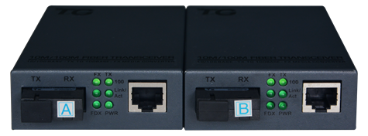

# **SF1002TS-SC**

Fast Optical Single fiber transceiver-SC

## Products Description

The 100M standard optical fiber transceiver adopts a high-strength IP40 protective metal shell, supports Auto-Negotiation adaptive technology, and a comprehensive LED status indicator, which can provide a flexible and stable solution for your Ethernet connection. The product supports DC 5V power input to increase the reliability of the communication network. It supports 1 100M RJ45 electrical port and 1 100M 1*9 SC optical port, which can flexibly combine optoelectronic products according to business port requirements. This product adopts the network scheme of the well-known brand-name manufacturers in the industry, and the operating temperature range is -25℃～60℃, which can meet the requirements of various environmental scenes and provide convenient Ethernet communication solutions.

## Main Features

* IP40 grade protection,metal shell.
* Low power consumption.
* Wide temperature operation: -25 to 60°C.

## Product Specifications

|  |  |
| --- | --- |
| **Product Information** | |
| Product Model | **SF1002TS-SC** |
| **Hardware specifications** | |
| Fixed port | 1*10/100 Base-TX ports  1*100Base-FX SC Port |
| Exchange capacity | 0.4Gbps |
| Forwarding mode | Full wire speed store and forward |
| Forwarding rate | 10M:14880pps/port |
| 100M:148809pps/port |
| 1000M:1488095pps/port |
| Temperature | Operating temperature: (-25 - 60)°C  Storage temperature: (-40 - 70)°C |
| Humidity | Operating humidity: (10% - 90%) RH, non-condensing  Storage humidity: (5% - 90%) % RH, non-condensing |
| Physical dimension | 94(L)*70(W)*25(H)mm |
| Input power | DC:5V/1A |
| Total Weight | <0.2Kg |

## Order Information

|  |  |
| --- | --- |
| **Product Information** | **Detailed information** |
| SF1002TS-SC | Fast Optical Single fiber transceiver,20KM, (20km, SC),DC 5V/1A.（Pair） |

|  |
| --- |
| **Shenzhen TG-NET Botone Technology CO. Ltd.**  3rd Floor,No.17,Langrong Road, Xinshi Community,Dalang Street,Longhua District,Shenzhen  Website: http://www.tg-net.net  E-mail: cherry.tan@tg-net.cn |