

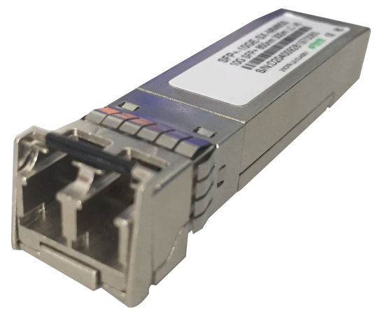

# **SFP+ Module**

## Products Description

Standard SFP+ 10GE module, used for campus network SFP+ optical fiber interface connection.

## Main Features

* Comply with the standard IEEE 802.3ae 10GBASE-SR/10GBASE-LR protocol.
* Comply with SFF-8431 electrical interface standard.
* Highly reliable, hot-swappable.
* All metal shell, with excellent EMI performance.
* Low power consumption.
* Wide temperature operation: -5 to 70℃.

## Product Specifications

|  |  |  |
| --- | --- | --- |
| **Product Information** | | |
| Product Model | **SFP+-10GE-SX-MM850** | **SFP+-10GE-LX-SM1310** |
| **Hardware specifications** | | |
| Module type | Multimode | Single mode |
| Transmission medium | optical fiber | optical fiber |
| Beam wavelength | 850nm | 1310nm |
| Package type | SFP+ | SFP+ |
| Interface rate | 10G | 10G |
| Export type | Dual core-LC-LC | Dual core-LC-LC |
| Transmission distance | 300M | 10KM |
| Temperature | -5-70℃ | -5-70℃ |

## Order Information

|  |  |
| --- | --- |
| **Product Information** | **Detailed information** |
| SFP+-10GE-SX-MM850 | SFP+ Module(850nm,300m,LC) |
| SFP+-10GE-LX-SM1310 | SFP+ Module(1310nm,10km,LC) |

|  |
| --- |
| **Shenzhen TG-NET Botone Technology CO. Ltd.**  3rd Floor,No.17,Langrong Road, Xinshi Community,Dalang Street,Longhua District,Shenzhen  Website: http://www.tg-net.net  E-mail: cherry.tan@tg-net.cn |