

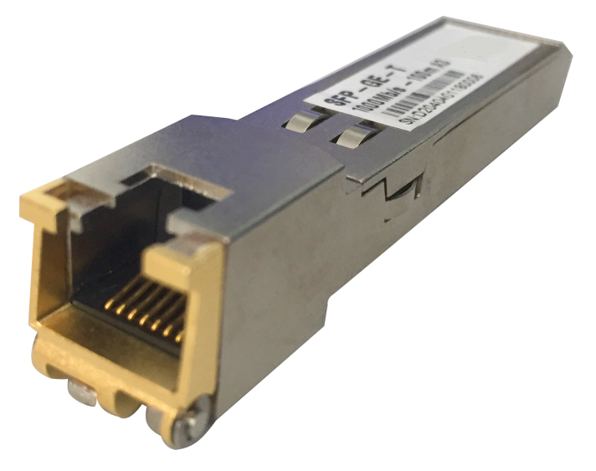

# **SFP-GE-T**

## Products Description

SFP-GE-T gigabit electrical port module (RJ45), used in switches and other network equipment SFP gigabit optical fiber interface, converted to gigabit RJ45 Ethernet port;

## Main Features

* Up to 1.25Gb/s bi-directional data links
* Hot-pluggable SFP footprint
* TX Disable and RX Los/without Los function
* Fully metallic enclosure for low EMI
* Low power dissipation (1.05 W typical)
* Compact RJ-45 connector assembly
* Access to physical layer IC via 2-wire serial bus
* Operating case temperature range of 0 °C to +70 °C (Commercial) or -20°C to +85°C (Extend)

## Product Specifications

**Pin Descriptions**

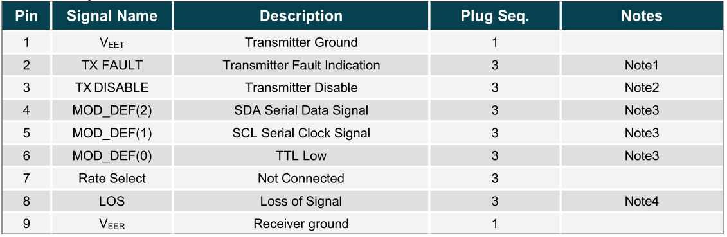

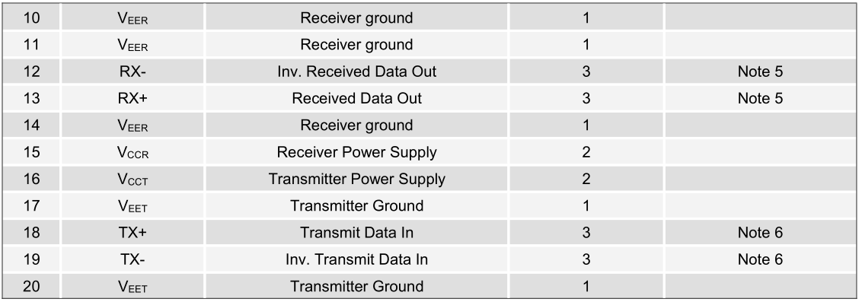

**+3.3V Volt Electrical Power Interface**

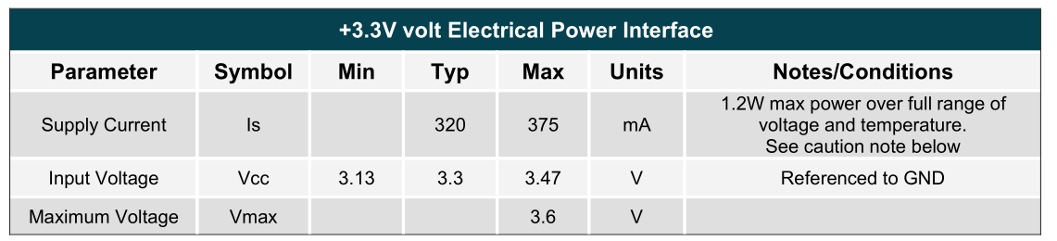

**Mechanical Specifications**

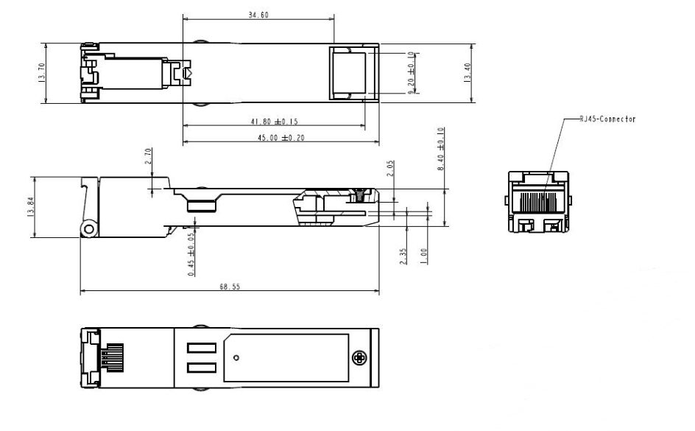

## Order Information

|  |  |
| --- | --- |
| **Product Information** | **Detailed information** |
| SFP-GE-T | SFP to 1000BASE-T |

|  |
| --- |
| **Shenzhen TG-NET Botone Technology CO. Ltd.**  3rd Floor,No.17,Langrong Road, Xinshi Community,Dalang Street,Longhua District,Shenzhen  Website: http://www.tg-net.net  E-mail: cherry.tan@tg-net.cn |