

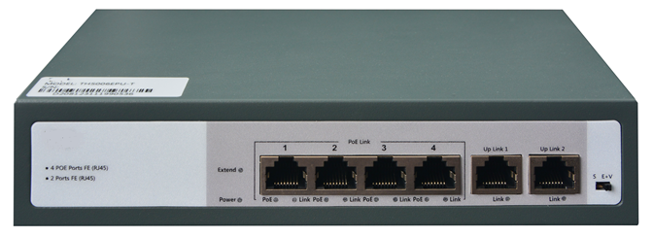

SF1206TP
6-Port 10/100Mbps Unmanaged POE Switch

Products Description
SF1206TP is a dedicated 100M Ethernet access switch for security with PoE power supply function. SF1206TP provides 4 downlink ports and 2 uplink ports, the downlink ports are 10/100Mbps PoE network ports, and the uplink ports are 2 10/100Mbps electrical ports. The uplink port can be connected to other specifications of switches, ordinary PCs and other terminals, and it can also be connected to NVR security equipment. This design conforms to the characteristics of network construction in the security industry, and the port utilization is extremely high. SF1206TP supports IEEE 802.3af/at Ethernet power supply standard, supports 48V national standard power supply, and the power supply distance is greater than 100 meters. SF1206TP only powers 802.3af/at standard terminal equipment, and seamlessly connects with IP network surveillance cameras, network high-definition cameras and security monitoring equipment.

Main Features
- Transmitting electrical power together with data through a single network cable, free of power lines.
- Compatible with both IEEE802.3at(30W) and IEEE802.3af(15.4W), can supply power to PDs under these two standards.
- Automatically detect and supply power to IEEE802.3at and IEEE 802.3af compliant powered devices(PDs).
- Advanced SAFC function, only supply power to IEEE 802.3af/at compliant PDs, no worry about damaging other private standard PoE devices or devices without PoE function.
- Support port power supply prioritization, guarantee the continuous power supply of key nodes.
- Up to 100m network cable transmitting distance, support flexible network expansion without power line deployment concerns. Users can freely fix their wireless APs, IP cameras or other end devices on the wall or ceiling.
- Built-in PSE power supply module, plug-and play design, easy to install.
- High security performance defending against power surge.

Product Specifications
Product Information
Product Model | SF1206TP
Hardware specifications
Fixed Ports | 4*10/100 Base-T ports(POE/POE+)  2*10/100 Base-T ports
Max Output Power(single port) | 30W
Total Power Consumption | 72W
PoE Pin-out | 1/2(+),3/6(-)
Switching capacity | 1.2Gbps
Forwarding Rate | 0.9Mpps
Temperature | Operating temperature: (-10 - 50)°C  Storage temperature: (-40 - 70)°C
Humidity | Operating humidity: (10% - 90%) RH, non-condensing  Storage humidity: (5% - 90%) % RH, non-condensing
Dimensions(L*W*H) | 200(L)*118(W)*44(H)mm
Power | AC:100～240VAC,50～60Hz
Power consumption | 72W output the whole device
Weight | <0.65Kg
Lightning protection | 4KV
MAC address table | 2K
LED Indicator | Power,Link/Act
Software specifications
Standard | IEEE 802.3, IEEE 802.3u, IEEE 802.3x, IEEE 802.3ab, IEEE 802.3af, IEEE 802.3at
Forwarding mode | Store-and-forward
Special feature | VLAN isolation
Special feature | 250 meters long distance transmission

Order Information
Product Information | Detailed information
SF1206TP | 4*10/100 Base-TX ports(POE/POE+), 2*10/100 Base-TX ports, IEEE 802.3af/at,Total Output Power:72W.

Shenzhen TG-NET Botone Technology CO. Ltd.
3rd Floor,No.17,Langrong Road, Xinshi Community,Dalang Street,Longhua District,Shenzhen

Website: http://www.tg-net.net
E-mail: cherry.tan@tg-net.cn

