

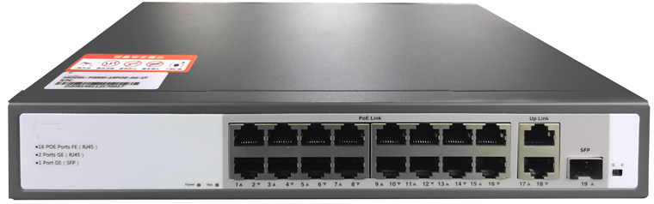

# **SFG1219DP**

16FE+2GE+1SFP Unmanaged POE Switch

## Products Description

SFG1219DP is a Gigabit uplink unmanaged POE switch launched by TG, which can provide 16 POE ports, all POE ports comply with IEEE802.3af/at standard, and support optical fiber uplink. It can supply power to POE terminal devices such as wireless APs, web cameras, VoIP phones, and handheld computers through the network cable. The transmission distance is 100m, the installation is simple, and it is plug and play. It is very suitable for security monitoring and other industries.

## Main Features

* Transmitting electrical power together with data through a single network cable, free of power lines.
* Compatible with both IEEE802.3at(30W) and IEEE802.3af(15.4W), can supply power to PDs under these two standards.
* Automatically detect and supply power to IEEE802.3at and IEEE 802.3af compliant powered devices(PDs).
* Advanced SAFC function, only supply power to IEEE 802.3af/at compliant PDs, no worry about damaging other private standard PoE devices or devices without PoE function.
* Support port power supply prioritization, guarantee the continuous power supply of key nodes.
* Up to 100m network cable transmitting distance, support flexible network expansion without power line deployment concerns. Users can freely fix their wireless APs, IP cameras or other end devices on the wall or ceiling.
* Built-in PSE power supply module, plug-and play design, easy to install.
* High security performance defending against power surge.

## Product Specifications

|  |  |
| --- | --- |
| **Product Information** | |
| Product Model | **SFG1219DP** |
| **Hardware specifications** | |
| Fixed Ports | 16*10/100 Base-TX ports(POE/POE+)  2*10/100/1000 Base-T ports  1* 1000 Base-X SFP ports |
| Max Output Power(single port) | 30W |
| Total Power Consumption | 250W |
| PoE Pin-out | 1/2(+),3/6(-) |
| Switching capacity | 9.2Gbps |
| Forwarding Rate | 6.85Mpps |
| Temperature | Operating temperature: (-10 - 50)°C  Storage temperature: (-40 - 70)°C |
| Humidity | Operating humidity: (10% - 90%) RH, non-condensing  Storage humidity: (5% - 90%) % RH, non-condensing |
| Dimensions(L*W*H) | 270(L)*181(W)*44(H)mm |
| Power | AC:100～240VAC,50～60Hz |
| Power consumption | 250W output the whole device |
| Weight | <2Kg |
| Lightning protection | 6KV |
| MAC address table | 2K |
| LED Indicator | Power,Link/Act |
| **Software specifications** | |
| Standard | IEEE 802.3, IEEE 802.3u, IEEE 802.3x, IEEE 802.3ab, IEEE 802.3af, IEEE 802.3at |
| Forwarding mode | Store-and-forward |
| Special feature | Watchdog(Ai Port detection) |
| 250 meters long distance transmission |

## Order Information

|  |  |
| --- | --- |
| **Product Information** | **Detailed information** |
| SFG1219DP | 16*10/100 Base-TX ports(POE/POE+), 2*10/100/1000 Base-T ports, 1* 1000 Base-X SFP ports, IEEE 802.3af/at,Total Output Power:250W. |
| **Transceivers** | |
| SFP-GE-SX-MM850 | 1000BASE-SX SFP Transceiver, Multi-Mode (850nm, 550m, LC) |
| SFP-GE-LX-SM1310 | 1000BASE-LX SFP Transceiver, Single Mode (1310nm, 20km, LC) |

|  |
| --- |
| **Shenzhen TG-NET Botone Technology CO. Ltd.**  3rd Floor,No.17,Langrong Road, Xinshi Community,Dalang Street,Longhua District,Shenzhen  Website: http://www.tg-net.net  E-mail: cherry.tan@tg-net.cn |